Radiocommunication Study Groups
Received: 3 November 2010  Subject: Questions ITU-R 202-3/3, ITU-R 225-5/3 | Document 3J/140-E  Document 3L/70-E
 | 4 November 2010
 | English only
Brazil (Federative Republic of)
Measurements of Medium Wave Field Strength
in a Dense Urban Area

1 Introduction
This document describes the experimental setup and presents preliminary results of medium wave propagation measurements campaigns that are being carried out Brazil. A hybrid signal composed of an analog AM signal and a digital DRM signal, with the same content, were broadcasted in diurnal and nocturnal transmissions.
The experiment is part of a series of field trials that are being conducted by the Brazilian Government to evaluate the performance of DRM standard, which includes campaigns at MW, HF and VHF frequency bands in the cities of São Paulo, Rio de Janeiro and Belo Horizonte.
Results presented here correspond to measurements of field strength, signal-to-noise ratio and audio quality at MW from the first campaign at São Paulo.
The tests were conducted by the National Institute o Metrology (Inmetro), the National Institute of Science and Technology in Wireless Communications (INCT-CSF) and the public broadcaster Padre Anchieta Radio Foundation (Radio Cultura), whit support from ANATEL and supervision of the Ministry of Communications.

2 Measurements setup
The transmissions for these trials were done from the Medium Wave transmitter station that Radio Cultura at South-East of São Paulo City (Figure 1).

Figure 1
Transmitter location
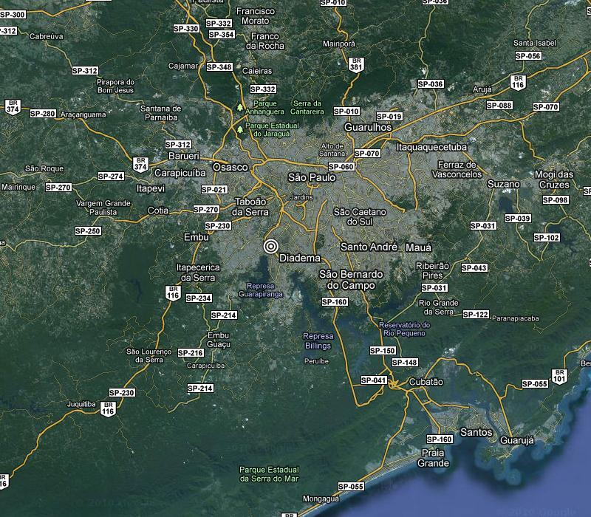

The radio station transmitter consists of two Harris 3DX-50 transmitters, which outputs are added in a coupler. The power of each 3DX-50 is 50 kW giving a total transmitter output power of 100 kW. A Digidia DRM content server and a Digidia DRM modulator generated the DRM signal. The modulator was connected to one of the two 3DX-50. Thus, the maximum transmission power was 50 kW. Table 1 shows the main technical characteristics of the transmission setup.
Table 1
Transmitter setup
Transmitter site | São Paulo
Broadcaster | Radio Cultura
Transmission centre coordinates | 46°42’52”W ; 23°40’35”S
AM Frequency | 1200 kHz
AM transmission power (Day/Night) | 50 kW / 20 kW
DRM Frequency | 1210 kHz
DRM transmission power (Day/Night) | 3.15 kW / 1.26 kW
Radiating system | Vertical Monopole (70 m height)
Transmission scheduling | 24/7

The tests were made in simulcast mode. The DRM signal was transmitted on the adjacent channel at 1 210 kHz. The DRM signal was modified in amplitude by spectral shaping, decreasing the DRM signal strength in the vicinity of the AM signal to cause less interference to AM receivers. Although the DRM signal is degraded by about 2 dB due to the shaping, it allows reducing the protection ratio to 12 dB (the typical protection ratio for DRM in MW is 16 dB). The DRM signal strength can be increased in 4 dB, providing an overall improvement in DRM signal reception of approximately 2 dB.
Two DRM transmission modes were used for daytime and another two for nighttime. For each period two transmission modes were used: a relatively robust mode (16 QAM in the MSC channel) and a high bit-rate channel (64 QAM modulation in the MSC channel). The daytime modes are based on robustness mode A, while the nighttime modes are based on B robustness mode, following the DRM standard recommendation ‎0. The details of these modes are shown on Table 2.
Table 2
DRM transmission modes
Name | OFDM Robustness Mode | Bandwidth | MSC Modulation | SDC Modulation | Code Rate | Interleaving | Bit-rate (kbps) | Audio
DAY16 | A | 10 kHz | 16-QAM | 4-QAM | 0,62 | Long | 18,4 | P. Stereo
DAY64 | A | 10 kHz | 64-QAM | 16-QAM | 0.6 | Long | 26,5 | Stereo
NIGHT16 | B | 10 kHz | 16-QAM | 4-QAM | 0,62 | Long | 14,5 | Mono
NIGHT64 | B | 10 kHz | 64-QAM | 16-QAM | 0,6 | Long | 20,4 | P. Stereo

To measure the received signals a mobile unit was used. The two main components of the reception setup are a professional DRM receiver and a spectrum analyzer. DRM receiver consists of an AOR7030 front-end and a Fraunhofer Software Radio running on a laptop. The spectrum analyzer is an Anritsu MS2724B.
Figure 4 shows a scheme of the receiver setup. A calibrated double loop active antenna, with an omni-directional radiation pattern, is used to receive the signal. The antenna can be connection is switched between the two measuring devices, the DRM receiver and the spectrum analyzer.

Figure 2
Receiver setup
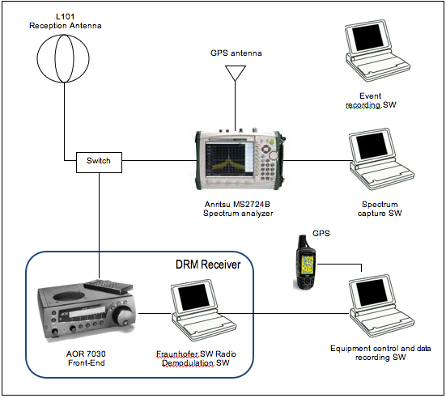

3 Methodology
A software tool running on a laptop records the spectrum analyzer data are recorded and the time and location information provided by a GPS. Another laptop controls the DRM receiver and records the data generated by it. The software adds the position information generated by a GPS to the records. Finally a third laptop is used to the input of information about events along the route (passing through tunnels, crossings under power lines, etc), that is, any additional information that may help to understand the results and cannot be recorded automatically. A technician is responsible for manually input these events.
The trials included both mobile and static measurements. In this document however, only static reception results are shown. Measurements were performed in two types of routes: radial routes, to analyze signal behavior with distance to the transmitter and define the coverage area; and local routes to evaluate the effect of different reception environments on DRM signal reception. All the daytime routes are shown on Figure 3. During the night measurements were performed in three routes, 7, 8 and 9, very similar to routes 2, 8 and 5 respectively.
The quality of received audio was also analyzed using the AQ parameter, which gives the percentage of correctly received audio frames. An AQ factor of 98% or better is considered to allow for good reception.

Figure 3
Measurements routes
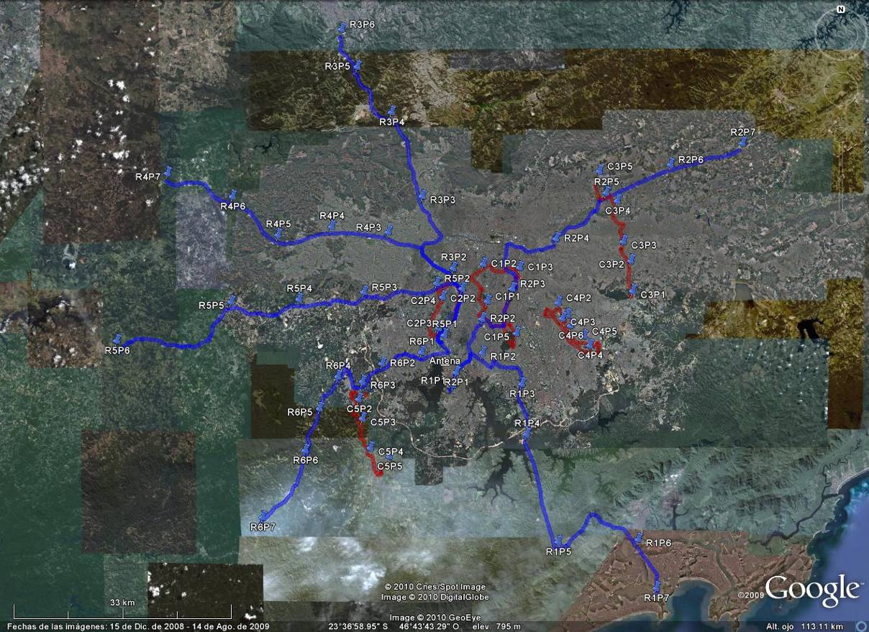

4 Field strength measurements results
Results of the field strength measurements at 85 fixed points along the six daytime measurements routes are shown in Figure 4 and Figure 5, corresponding to the 16 QAM signal reception at daytime and nighttime, respectively, and Figure 6 and Figure 7, corresponding to the 64 QAM signal reception at daytime and nighttime, respectively. These figures also show the field strength predicted by the method in Rec. ITU-R P.328-9. Table 3 shows the parameters used in the calculation. The ground conductivity was obtained from Rec. ITU-R P.832-2.
Table 3
Parameters for field strength prediction
Relative ground permittivity | 15
Ground conductivity | 1 mS/m
Transmitted power | Daytime 50 kW  Night time 20 kW
Characteristic field | 315 mV/m (110 dBµV/m)

Figure 4
Received field strength (16 QAM - daytime) and Recommendation ITU-R P.368 prediction
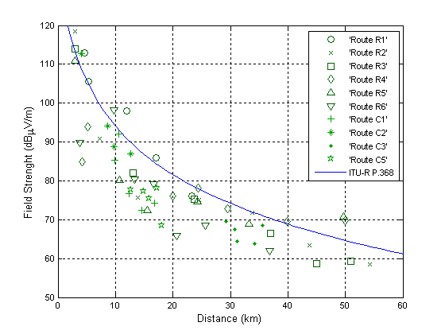
Figure 5
Received field strength (16 QAM - night-time) and Recommendation ITU-R P.368 prediction
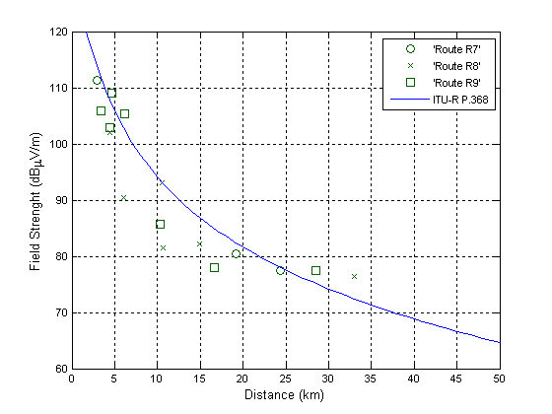

Figure 6
Received field strength (64 QAM - daytime) and Recommendation ITU-R P.368 prediction
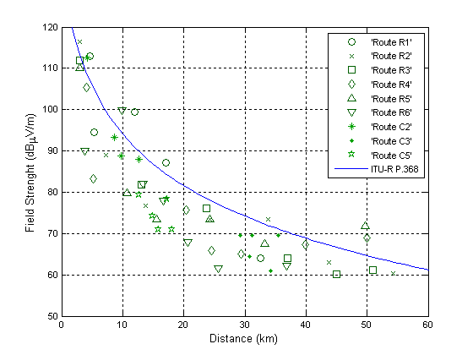
Figure 7
Received field strength (64 QAM - night-time) and Recommendation ITU-R P.368 prediction
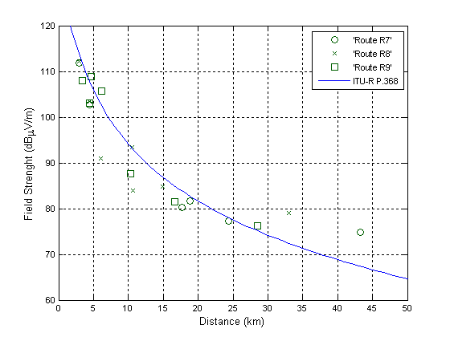
The measured received field strengths are very similar for the two modulations, as expected. The predictions of Rec. ITU-R P.368 overestimate the received field at daytime and show better agreement at night-time.

5 SNR and audio quality measurements results
The measured audio quality achieved at each measurement point is indicated in Figure 8, for the 16 QAM signal, and Figure 9, for the 64 QAM signal, as related to received field strength and signal to noise ratio. Good reception of the 16 QAM signal requires field strengths above 60 dBμV/m and SNR above approximately 15 dB. For the 64 QAM signal the SNR threshold becomes approximately 20 dB.
Figure 8
Audio quality dependency on field strength and SNR (16 QAM)
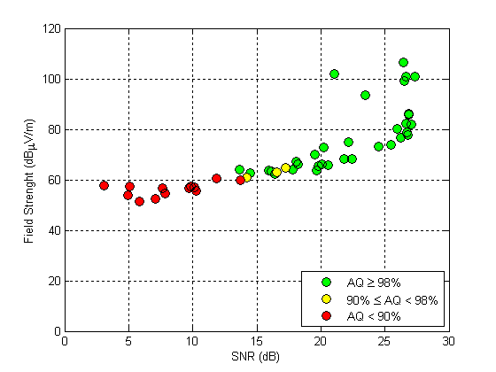
Figure 9
Audio quality dependency on field strength and SNR (64 QAM)
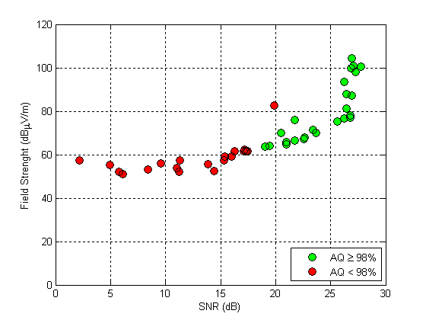

6 Conclusions
The measured values received field strength are significantly lower than those predicted by Rec. ITU-R P.328-9. Sao Paulo is a huge city, very densely urbanized with lots of skyscrapers. This may be the reason for the additional attenuation of the signal.
The experiments underway in Brazil also include two another trials in MW and trials in VHF band II and 26 MHz band in two different regions. The analysis of the data collected in these trials, as well as the mobile test results, is still being performed and will soon be available. The results will allow a more detailed analysis of the accuracy of Rec. ITU-R P.328-9 for these environments, as well as the modeling of the variability of the field strength due to the ground-wave field with location or with time in mobile reception conditions.

7 Acknowledgements
The studies presented in this document are being carried out by the National Institute of Metrology, Standardization and Industrial Quality – INMETRO and the National Institute of Science and Technology in Wireless Communications – INCT-CSF - Brazil. The field trials were done in cooperation with the public broadcaster Padre Anchieta Foundation Radio, the Ministry of Communication and Anatel.
References
[1] ETSI ES 201 980: “Digital Radio Mondiale (DRM); System Specification”, v3.1.1, 2009.
[2] Recommendation ITU-R P.368-9, “Ground-wave propagation curves for frequencies between 10 kHz and 30 MHz”.
[3] Recommendation ITU-R P.832-2, “World atlas of ground conductivities”.

Contacts: | Da Silva Mello LUIZ  CETUC-PUC/Rio  Brazil  Pontes Marlene  CETUC-PUC/Rio  Brazil | Tel.: +55 21 94701406  E-mail: mspontes@cetuc.puc-rio.br  Tel.: +55 21 88141057  E-mail: mspontes@cetuc.puc-rio.br

________________

