|  |  |
| --- | --- |
| **Radiocommunication Study Groups** |  |
|  |  |
|  |  |
| Received: 11 June 2012  Subject: Recommendation ITU-R P.832 | **Document 3L/13-E** |
| **12 June 2012** |
| **English only** |
| Iran ( Islamic Republic of) | |
| Relation between Ground conductivity map and slope map | |
|  | |

Introduction

According to Recommendation ITU-R P.368, the most important parameter to calculate Filed strength in Medium Frequency band is ground conductivity. There are some Worldwide maps to show ground conductivity in Recommendation ITU-R P.832 to calculate filed strength ,but these maps are not accurate & results does not match with measurement.

In this report a new method to allocate conductivity values to different type of ground is proposed. This method has experimented in I.R Iran.

Relation between Ground conductivity map and Slope map

According to Recommendations ITU-R P.832 and ITU-R P.368 Ground conductivity map depends on ground types.

The Sea, wet ground, dry ground, mountains, rock, seasonal water area and … are some types of ground that affect the field strength in Medium Frequencies.

All types of ground have a special conductivity and permittivity. To determine how to produce ground conductivity map there is a new method called Slope method. In this case we replace preferred ground conductivity map in ITU-R P.832 with Slope map created by GIS software.



In Islamic Republic of Iran, different type of ground is categorized to 7 types, each of which has a specific slope with corresponding ground conductivity as shown in table below:

|  |  |  |
| --- | --- | --- |
| Type of ground | Ground Conductivity | Related Slope* |
| Sea | 4000 mS/m | 0 degree |
| Very wet ground | 30 mS/m | 0-1 degree |
| Wet grounds | 10 mS/m | 1-3 degree |
| Dry grounds | 3 mS/m | 3-6 degree |
| Hills | 1mS/m | 6-15 degree |
| Mountains | 0.3 mS/m | 15-20 degree |
| Mountains with rocks | 0.1 mS/m | Over 20 degree |
| * To optimize slope map, water body map should be added with a conductivity of 100 mS. | | |

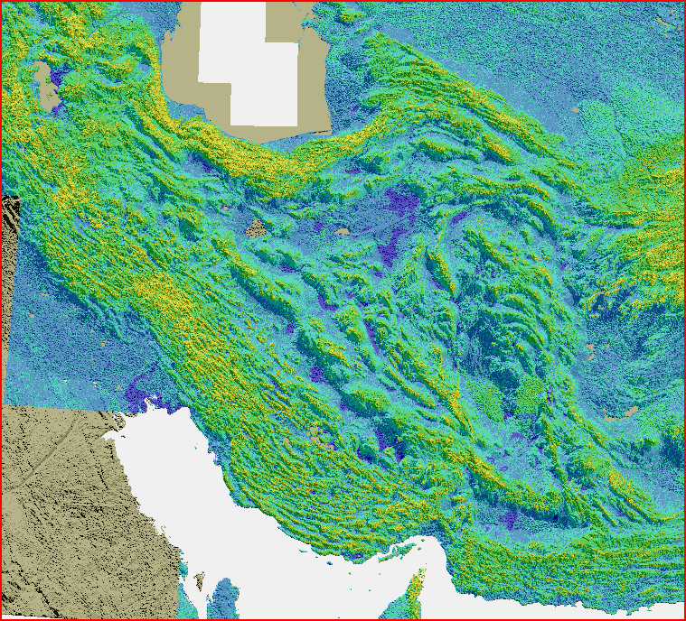

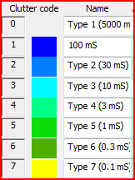

By using the new method and slope map (with 200 m accuracy), the predicted field strength is quite close to measured results. Furthermore, the border of coverage area estimated in this way, matches to that obtained by measurements in 90% of MF radio stations in I.R. of Iran.

According to measurement campaigns conducted in I.R of Iran, almost 70% of the measured values fall within the +/-3 dB around the predicted values.

There are some examples of comparison between Slope method and the method using old ITU ground conductivity maps:

|  |  |  |  |  |  |  |
| --- | --- | --- | --- | --- | --- | --- |
| Stations | Coverage Correlation** (Slope method) % | Coverage Correlation (old method) % | Standard deviation (Slope method) dB | Standard deviation (old method) dB | Average Error (Slope method) dB | Average Error (old method) dB |
| AzarShahr | 76 | 63 | 7.1 | 7.7 | -2.4 | 1.6 |
| Dorood | 96 | 30 | 1.04 | 7.89 | -0.19 | -7.8 |
| Ghazvin | 96 | 75 | 1.37 | 3.76 | -0.23 | 2.08 |
| Isfahan | 88 | 61 | 7.78 | 8.58 | 0.72 | 0.86 |
| KhoramAbad | 93 | 57 | 2.14 | 4.49 | 0.54 | 3.26 |
| Shooshtar | 85 | 44 | 2.78 | 4.53 | 0.73 | 4.39 |
| Tehran | 72 | 41 | 6.12 | 14.98 | -0.83 | 1.2 |
| Yasouj | 98 | 64 | 0.97 | 4.82 | 0.08 | 0.38 |
| ** Coverage Correlation: Correlation between estimated values and measurement. | | | | | | |

(accuracy of map: 1 000 m)

Conclusion

The method described above can help us to derive ground conductivity from the slope map in MF band.

This information is proposed to be included as a new appendix to Recommendation ITU-R P.832 or in a new or existing report.

______________