Radiocommunication Study Groups
Received: 12 June 2012 | Document 3L/14-E
 | 13 June 2012
 | English only
Brazil (Federative Republic of)
Measurements of Effective Ground Conductivity
in Brazil

1 Introduction
This information document provides results of effective ground conductivity obtained from the analysis of field intensity measurements, carried out in São Paulo, Brazil, at 1 200 kHz and 780 kHz. It is an initial effort to provide more accurate information for the planning of broadcast system at frequencies below 30 MHz in a region were the values of ground conductivity given in the world atlas presented in Rec. ITU-R 832-3 [1] show little detail.
It was found that, for some routes, the effective conductivity values derived from the measurements is significantly higher than those provided by Rec. ITU-R 832-3. As a consequence, the actual coverage area of the transmitter will be wider than that predicted in the licensing process. This might cause interference between existing analog systems and digital simulcast systems currently being deployed.
The tests were conducted by the National Institute of Metrology (Inmetro) and the National Institute of Science and Technology in Wireless Communications (INCT-CSF), with support from ANATEL and supervision of the Ministry of Communications.

2 Measurements campaigns
The measurements of field intensity at 1 200 kHz were performed along 6 radial routes with lengths up to 54 km. At 780 kHz, four additional routes with lengths reaching 67 km were used. The transmitting stations are located in a dense urban environment in the city of São Paulo, although some routes extend through rural areas.
Table I shows the transmitting stations characteristics. Table II presents a description of the measurement routes, which are depicted in Figs. 1 and 2.

TABLE i
Transmitting Stations characteristics
Parameter | Station #1 | Station #2
Frequency | 1 200 kHz | 780 kHz
Transmission power | 50 kW (day) | 43 kW (day)
Antenna type | Vertical monopole | Vertical monopole
Tower height | 70 m | 122 m
table II
Description of Measurement Routes
Station | Route ID | Orientation | Distance to the last site (km)
Station #1 | R1 | South | 46.9
 | R2 | East | 54.2
 | R3 | North | 36.9
 | R4 | Northwest | 49.9
 | R5 | West | 49.6
 | R6 | Southeast | 36.8
Station #2 | R2 | Southeast | 42.6
 | R3A/R3B | Northeast | 67.5
 | R6 | Southwest | 30.2
 | R7 | Northwest | 45.9
FIGURE 1
Measurement routes for Station #1

figure 2
Measurement routes for Station #2

Measurements were performed at 50 points along the different routes using a spectrum analyzer model ANRITSU MS2724B (9 kHz - 20 GHz) and omnidirectional active loop antenna. Data were combined with GPS information and recorded in a laptop. These instruments were mounted in a vehicle, which traveled along the routes stopping at the measurement points.
At low frequencies in the VLF, LF and MF bands, the main propagation mechanism is the surface (ground) wave. The electromagnetic wave does not disperse into space and boundary conditions relative to the ground conductivity require an almost vertical electric field. A simplified procedure for the computation of the electric field of a surface wave is described in [2]. Basically, the module of the electric field is obtained from eq. (1), where E₀ is the electric field in free space, given by (2).

E=E0 A (1)

E₀ (mV/m) = $\frac{\text{174}\sqrt{{\text{P}}_{\text{T}}\left(\text{kW}\right){\text{G}}_{\text{T}}}}{\text{d(km)}}$ (2)

The attenuation factor of the surface wave, A, depends on the electrical characteristics of the ground, including the conductivity [2]. This factor is not constant along the propagation path, changing according to the composition of the ground, the degree of moisture and salt concentration, among other factors.
The ground conductivity σ can be obtained from the measurements by inverting the field expression. Because the dependence of the field equation with respect to σ is complex, the inversion requires numerical computation (a function developed in Matlab® was used).

3 Results
The average (effective) ground conductivity [3] was calculated for each route by

$\text{σ=}\frac{{\text{σ}}_{\text{1}}{\text{d}}_{\text{1}}\text{+ }{\text{σ}}_{\text{2}}{\text{d}}_{\text{2}}\text{ +}{\text{ σ}}_{\text{3}}{\text{d}}_{\text{3}}\text{+ }{\text{… + σ}}_{\text{n}}{\text{d}}_{\text{n}}}{{\text{d}}_{\text{1}}\text{+ }{\text{d}}_{\text{2}}\text{+ }{\text{d}}_{\text{3}}\text{+ … }\text{+ }{\text{d}}_{\text{n}}}$ (3)

where σ_{i} (i = 1 to n) are the measured values at each point along the route. Table III presents the retrieved σ values.
TABLE III
Retrieved Average Ground Conductivities
Route | Assessed σ (mS/m)
Station #1
R1 | 2.8
R2 | 1.2
R3 | 1.5
R4 | 1.0
R5 | 1.0
R6 | 1.1
Station #2
R2 | 1.5
R3A | 0.6
R3B | 2.5
R6 | 1.2
R7 | 0.9

Figures 3 and 4 illustrate the effect of the ground conductivity on the values of field predicted using ITU-R Rec. P. 368-9 [4]. Figure 3 corresponds to route 6 (transmitter station 2), for which the average value of ground conductivity is almost the same suggested by the ITU-R Atlas (1 mS/m). For route 1 (transmitter station 1), the retrieved value of ground conductivity (2.8 mS/m) is significantly higher than the value recommended by the ITU-R (1 mS/m).
figure 3
Predicted and measurement field strength for route R6 (Station #2)
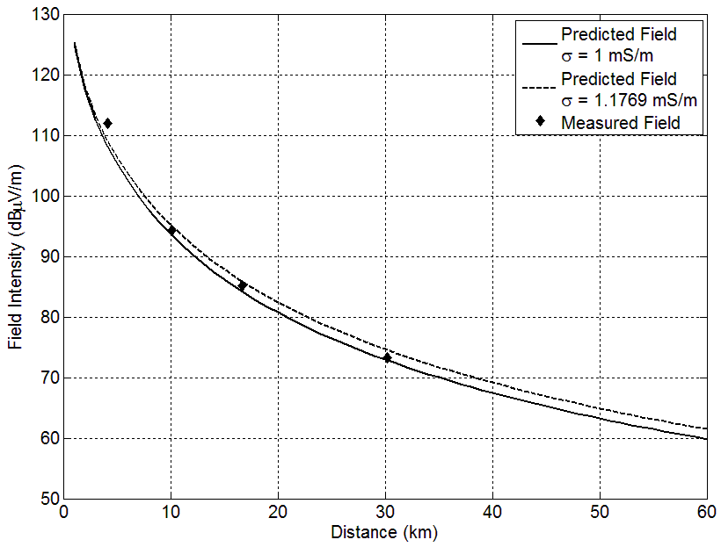
FIGURE 4
Predicted and measurement field strength for route R1 (Station #1)
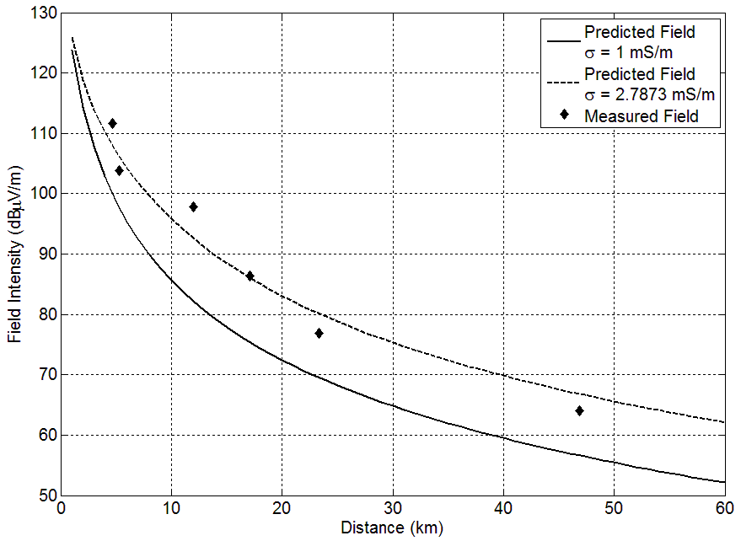

Mean and RMS errors between the measured values of field intensity and those predicted with the retrieved and recommended ground conductivity values are shown in Tables IV and V.

table IV
Mean Errors Between Measured and Predicted Fields with
Retrieved σ values and ITU-R σ values
Route | E (retrieved σ) vs.  E (measured) | E (ITU-R σ) vs.  E (measured)
R1 | 0.12 | -9.84
R2 | 0.08 | -1.97
R3 | -0.91 | -2.45
R4 | 0.31 | -0.58
R5 | -0.60 | 0.42
R6 | 0.57 | -1.46
R2 | -0.08 | -4.08
R3A | -2.67 | 7.28
R3B | 0.11 | 4.57
R6 | 0.04 | -1.48
R7 | -0.39 | 1.80
TABLE V
RMS Errors Between Measured and Predicted Fields with
Retrieved σ values and ITU-R σ values
Route | E (assessed σ) vs.  E (measured σ) | E (ITU σ) vs.  E (measured σ)
R1 | 3.29 | 10.38
R2 | 4.56 | 4.88
R3 | 4.33 | 5.72
R4 | 2.50 | 2.55
R5 | 3.71 | 3.66
R6 | 6.87 | 7.45
R2 | 5.23 | 6.61
R3A | 4.85 | 7.96
R3B | 5.00 | 6.93
R6 | 1.68 | 2.01
R7 | 5.39 | 5.69

4 Conclusions
Field strength measurements at 1 200 kHz and 780 kHz were used to retrieve the effective ground conductivity in and around a dense urban city in Brazil. For some measurement routes the retrieve conductivity is significantly higher than that provided by Rec. ITU-R P.832-3. A digital map of ground conductivity for the region will be obtained by bi-linear interpolation of the retrieved values.

References
[1] Recommendation ITU-R P.832-3: "World Atlas of Ground Conductivities", (02/2012).
[2] W. S. Gomes, A. L. P. S. Campos, and R. A. Martins, “Some Results of Effective Ground Conductive of Rio Grande do Norte State”, International Microwave and Optoelectronics Conference (IMOC 2011), Brazil, October 2011.
[3] D. Guerra, G. Prieto, I. Fernandez, J. M. Matias, P. Angueira, and J. L. Ordiales, “Medium wave DRM field test results in urban and rural environments,” IEEE Trans. Broadcasting, vol. 51, no. 4, pp. 431--438, Dec. 2005.
[4] Recommendation ITU-R P.368-9, “Ground-wave propagation curves for frequencies between 10 kHz and 30 MHz”.

Contacts: | da Silva Mello LUIZ  CETUC-PUC/Rio  Brazil  Pontes Marlene  CETUC-PUC/Rio  Brazil | Tel: +55 21 94701406  Email: mspontes@cetuc.puc-rio.br  Tel: +55 21 88141057  Email: mspontes@cetuc.puc-rio.br
_________________

